Flood monitoring system

**Flow chat :**



An ultrasonic sensor is an electronic device that measures the distance of a target object by emitting ultrasonic sound waves, and converts the reflected sound into an electrical signal. Ultrasonic waves travel faster than the speed of audible sound (i.e. the sound that humans can hear). Ultrasonic sensors have two main components: the transmitter (which emits the sound using piezoelectric crystals) and the receiver (which encounters the sound after it has travelled to and from the target).

In order to calculate the distance between the sensor and the object, the sensor measures the time it takes between the emission of the sound by the transmitter to its contact with the receiver. The formula for this calculation is [D = ½ T x C](https://www.arrow.com/en/research-and-events/articles/ultrasonic-sensors-how-they-work-and-how-to-use-them-with-arduino) (where D is the distance, T is the time, and C is the speed of sound ~ 343 meters/second). For example, if a scientist set up an ultrasonic sensor aimed at a box and it took 0.025 seconds for the sound to bounce back, the distance between the ultrasonic sensor and the box would be:

|  |
| --- |
| **D = 0.5 x 0.025 x 343** |

or about 4.2875 meters.

Block diagram :

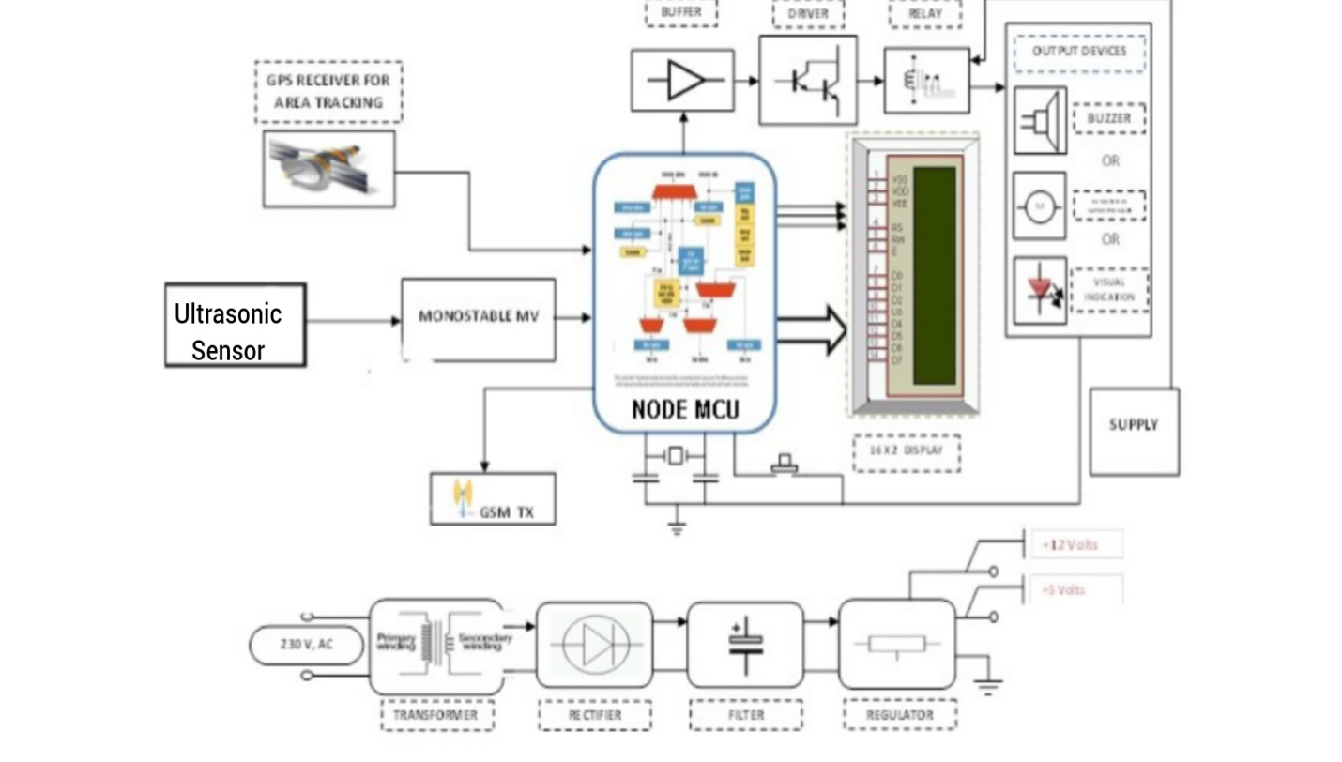

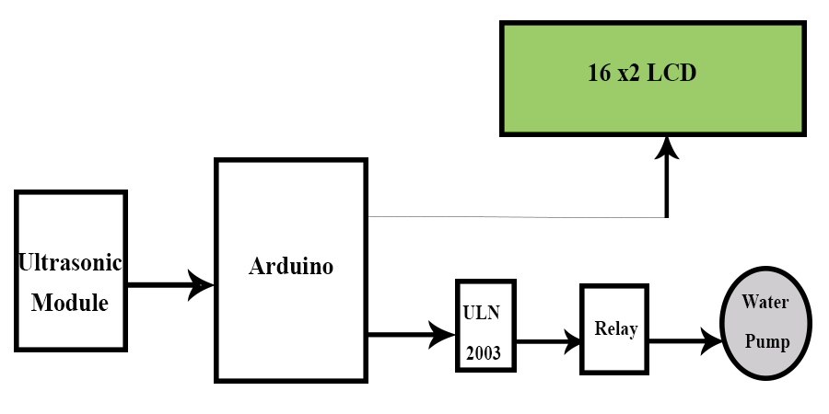

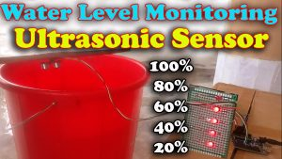

Ultrasonic sensor :

Ultrasonic sensor in this research used to detect water level condition. This sensor works by emitting ultrasonic waves and receive the signal reflected by an object. Delay time between transmitted and received ultrasonic wave can be analyzed to know the distance between sensors with object. Ultrasonic working



Ultrasonic working

This sensor transmit ultrasonic wave for 200 μs and then detect the reflection wave. Ultrasonic wave spread in the air with the velocity about 344 m/s (sound wave velocity), touch the object and reflected back to the sensor. That mechanism is used ultrasonic to measure the distance as below

S=(tIN x V) ÷ 2 (1)

Where

,

S= the distance between ultrasonic with object detected

V= sound wave velocity

tIN= time deviation wave transmit and receive

To measure water level on dam through reduce the height of the sensor with the height of calculating the distance of the sensor to the object (water). Reading Water Level (WS)